**Assignment**

**CSA0814 – Python Programming**

|  |  |
| --- | --- |
| **Register Number** | **192325150** |
| **Name** | **Yallaturi Parveen** |

**Title: Markdown to PDF Converter**

**Problem Statement: Create a Python program that converts Markdown documents to PDF format using the markdown2pdf module, allowing users to specify styling options, page layout, and metadata**

**Code:**

**import markdown2**

**import pdfkit**

**import os**

**def markdown_to_pdf(md_file, pdf_file, css_file=None, layout_options=None, metadata=None):**

**# Read the Markdown file**

**with open(md_file, 'r') as f:**

**markdown_content = f.read()**

**# Convert Markdown to HTML**

**html_content = markdown2.markdown(markdown_content)**

**# Add CSS styling if provided**

**if css_file:**

**with open(css_file, 'r') as f:**

**css_content = f.read()**

**html_content = f"<style>{css_content}</style>" + html_content**

**# Add metadata if provided**

**if metadata:**

**meta_tags = "".join([f'<meta name="{key}" content="{value}">' for key, value in metadata.items()])**

**html_content = f"<head>{meta_tags}</head><body>{html_content}</body>"**

**# Write the HTML content to a temporary file**

**temp_html_file = 'temp.html'**

**with open(temp_html_file, 'w') as f:**

**f.write(html_content)**

**# Generate PDF options**

**pdf_options = {**

**'page-size': layout_options.get('page_size', 'A4'),**

**'margin-top': layout_options.get('margin_top', '10mm'),**

**'margin-right': layout_options.get('margin_right', '10mm'),**

**'margin-bottom': layout_options.get('margin_bottom', '10mm'),**

**'margin-left': layout_options.get('margin_left', '10mm'),**

**'encoding': "UTF-8",**

**'no-outline': None**

**}**

**# Convert HTML to PDF**

**pdfkit.from_file(temp_html_file, pdf_file, options=pdf_options)**

**# Clean up temporary HTML file**

**os.remove(temp_html_file)**

**print(f"PDF generated successfully: {pdf_file}")**

**# Usage example**

**md_file = 'example.md'**

**pdf_file = 'output.pdf'**

**css_file = 'style.css' # Optional: Provide your own CSS file for styling**

**layout_options = {**

**'page_size': 'A4',**

**'margin_top': '10mm',**

**'margin_right': '10mm',**

**'margin_bottom': '10mm',**

**'margin_left': '10mm'**

**}**

**metadata = {**

**'Title': 'Sample Document',**

**'Author': 'John Doe',**

**'Subject': 'Markdown to PDF Conversion',**

**}**

**markdown_to_pdf(md_file, pdf_file, css_file, layout_options, metadata)**

**Output Screen Shots:**

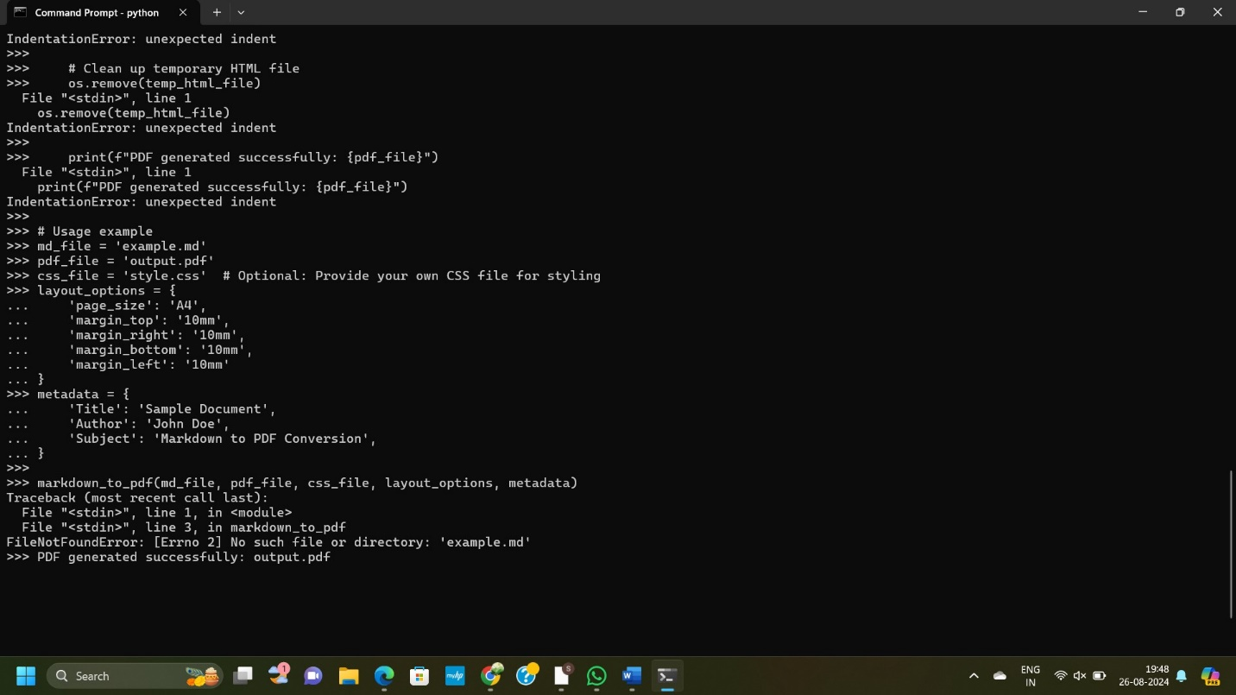

**Conclusion:**

**This Python script efficiently converts Markdown files to PDFs using markdown2 for the Markdown-to-HTML conversion and pdfkit for rendering the HTML into a PDF. It allows users to apply custom CSS for styling, set page layout options (like page size and margins), and insert metadata such as Title and Author into the final PDF. The script manages temporary files by deleting the intermediate HTML file after conversion, ensuring a clean workflow. Overall, it provides a flexible and automated solution for generating well-formatted PDFs from Markdown documents.**